2MP Fixed Dual-light Turret Network Camera IPC3612LB-AF28-DL-ECO
2MP Fixed Dual-light Turret Network Camera IPC3612LB-AF28-DL-ECO2

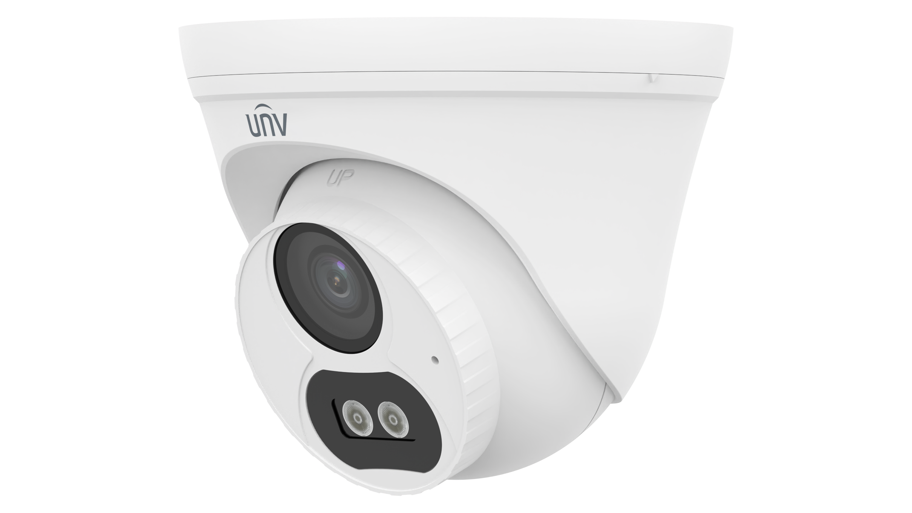

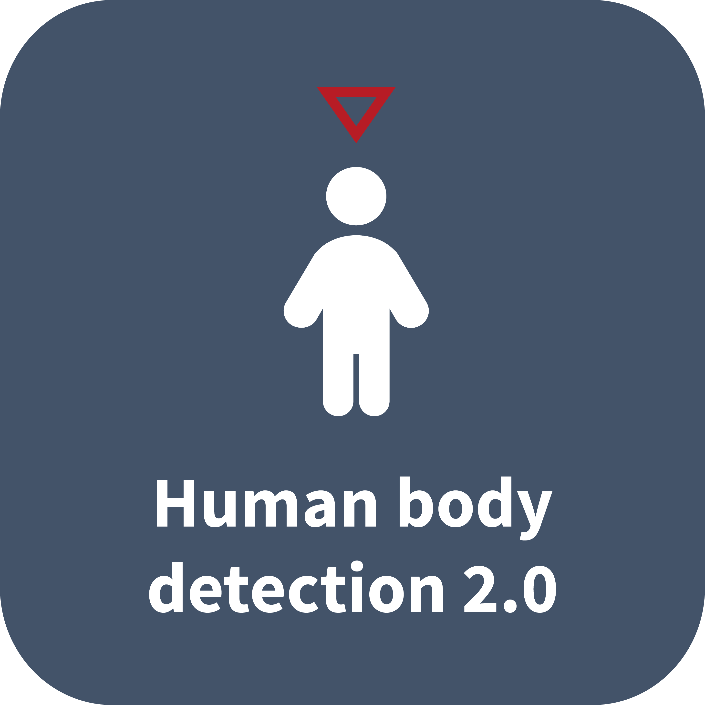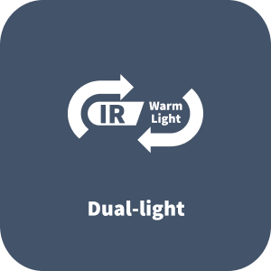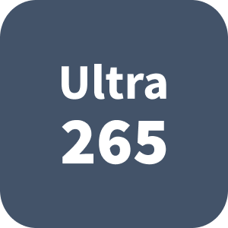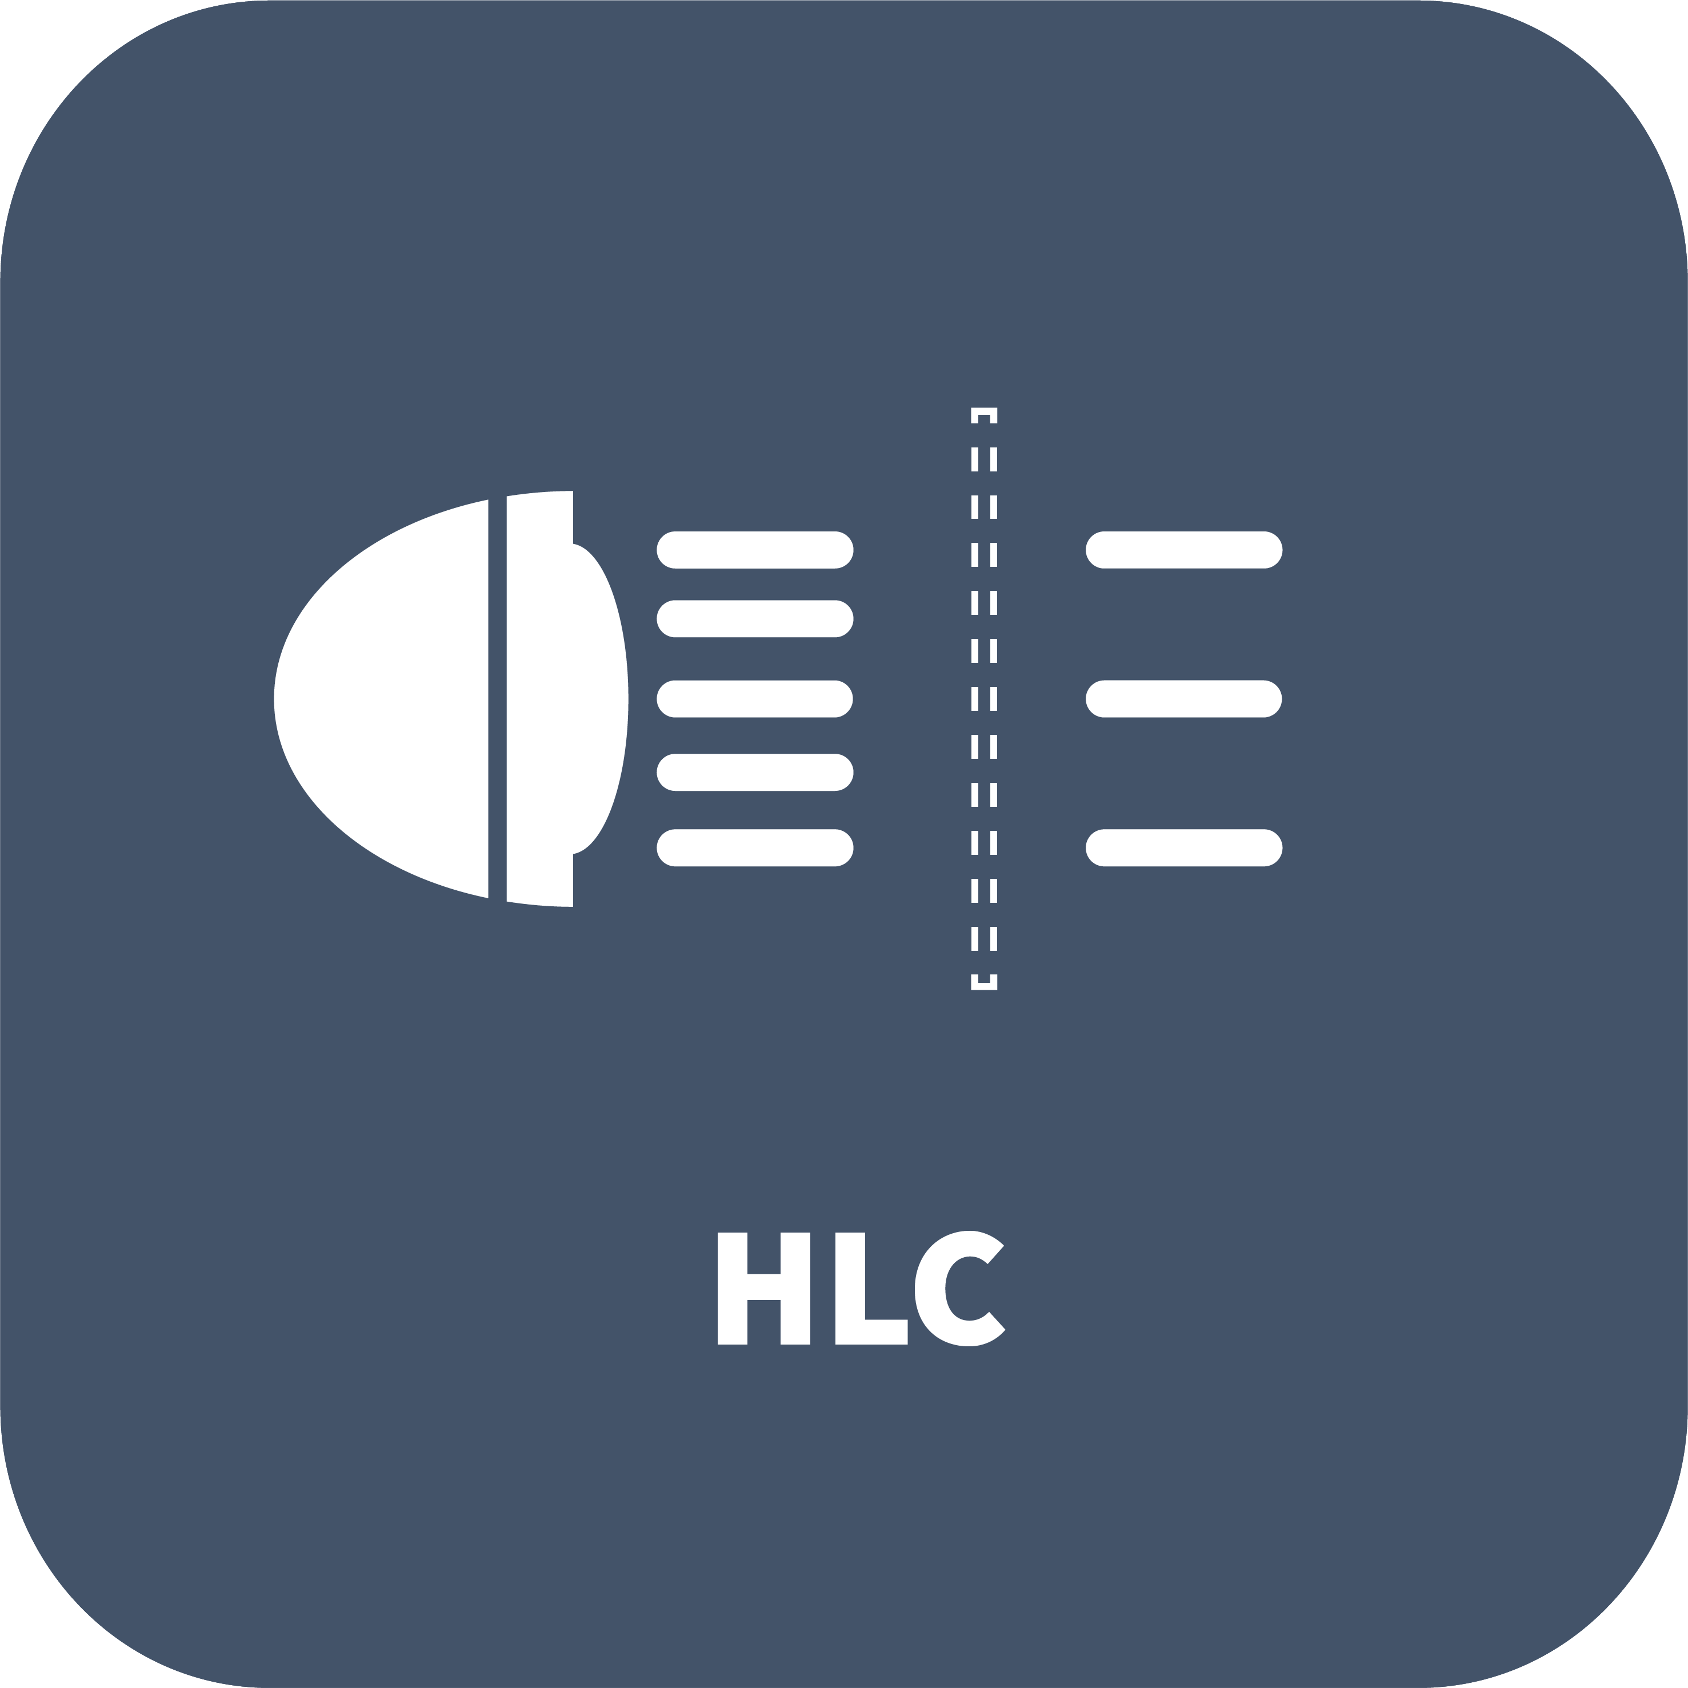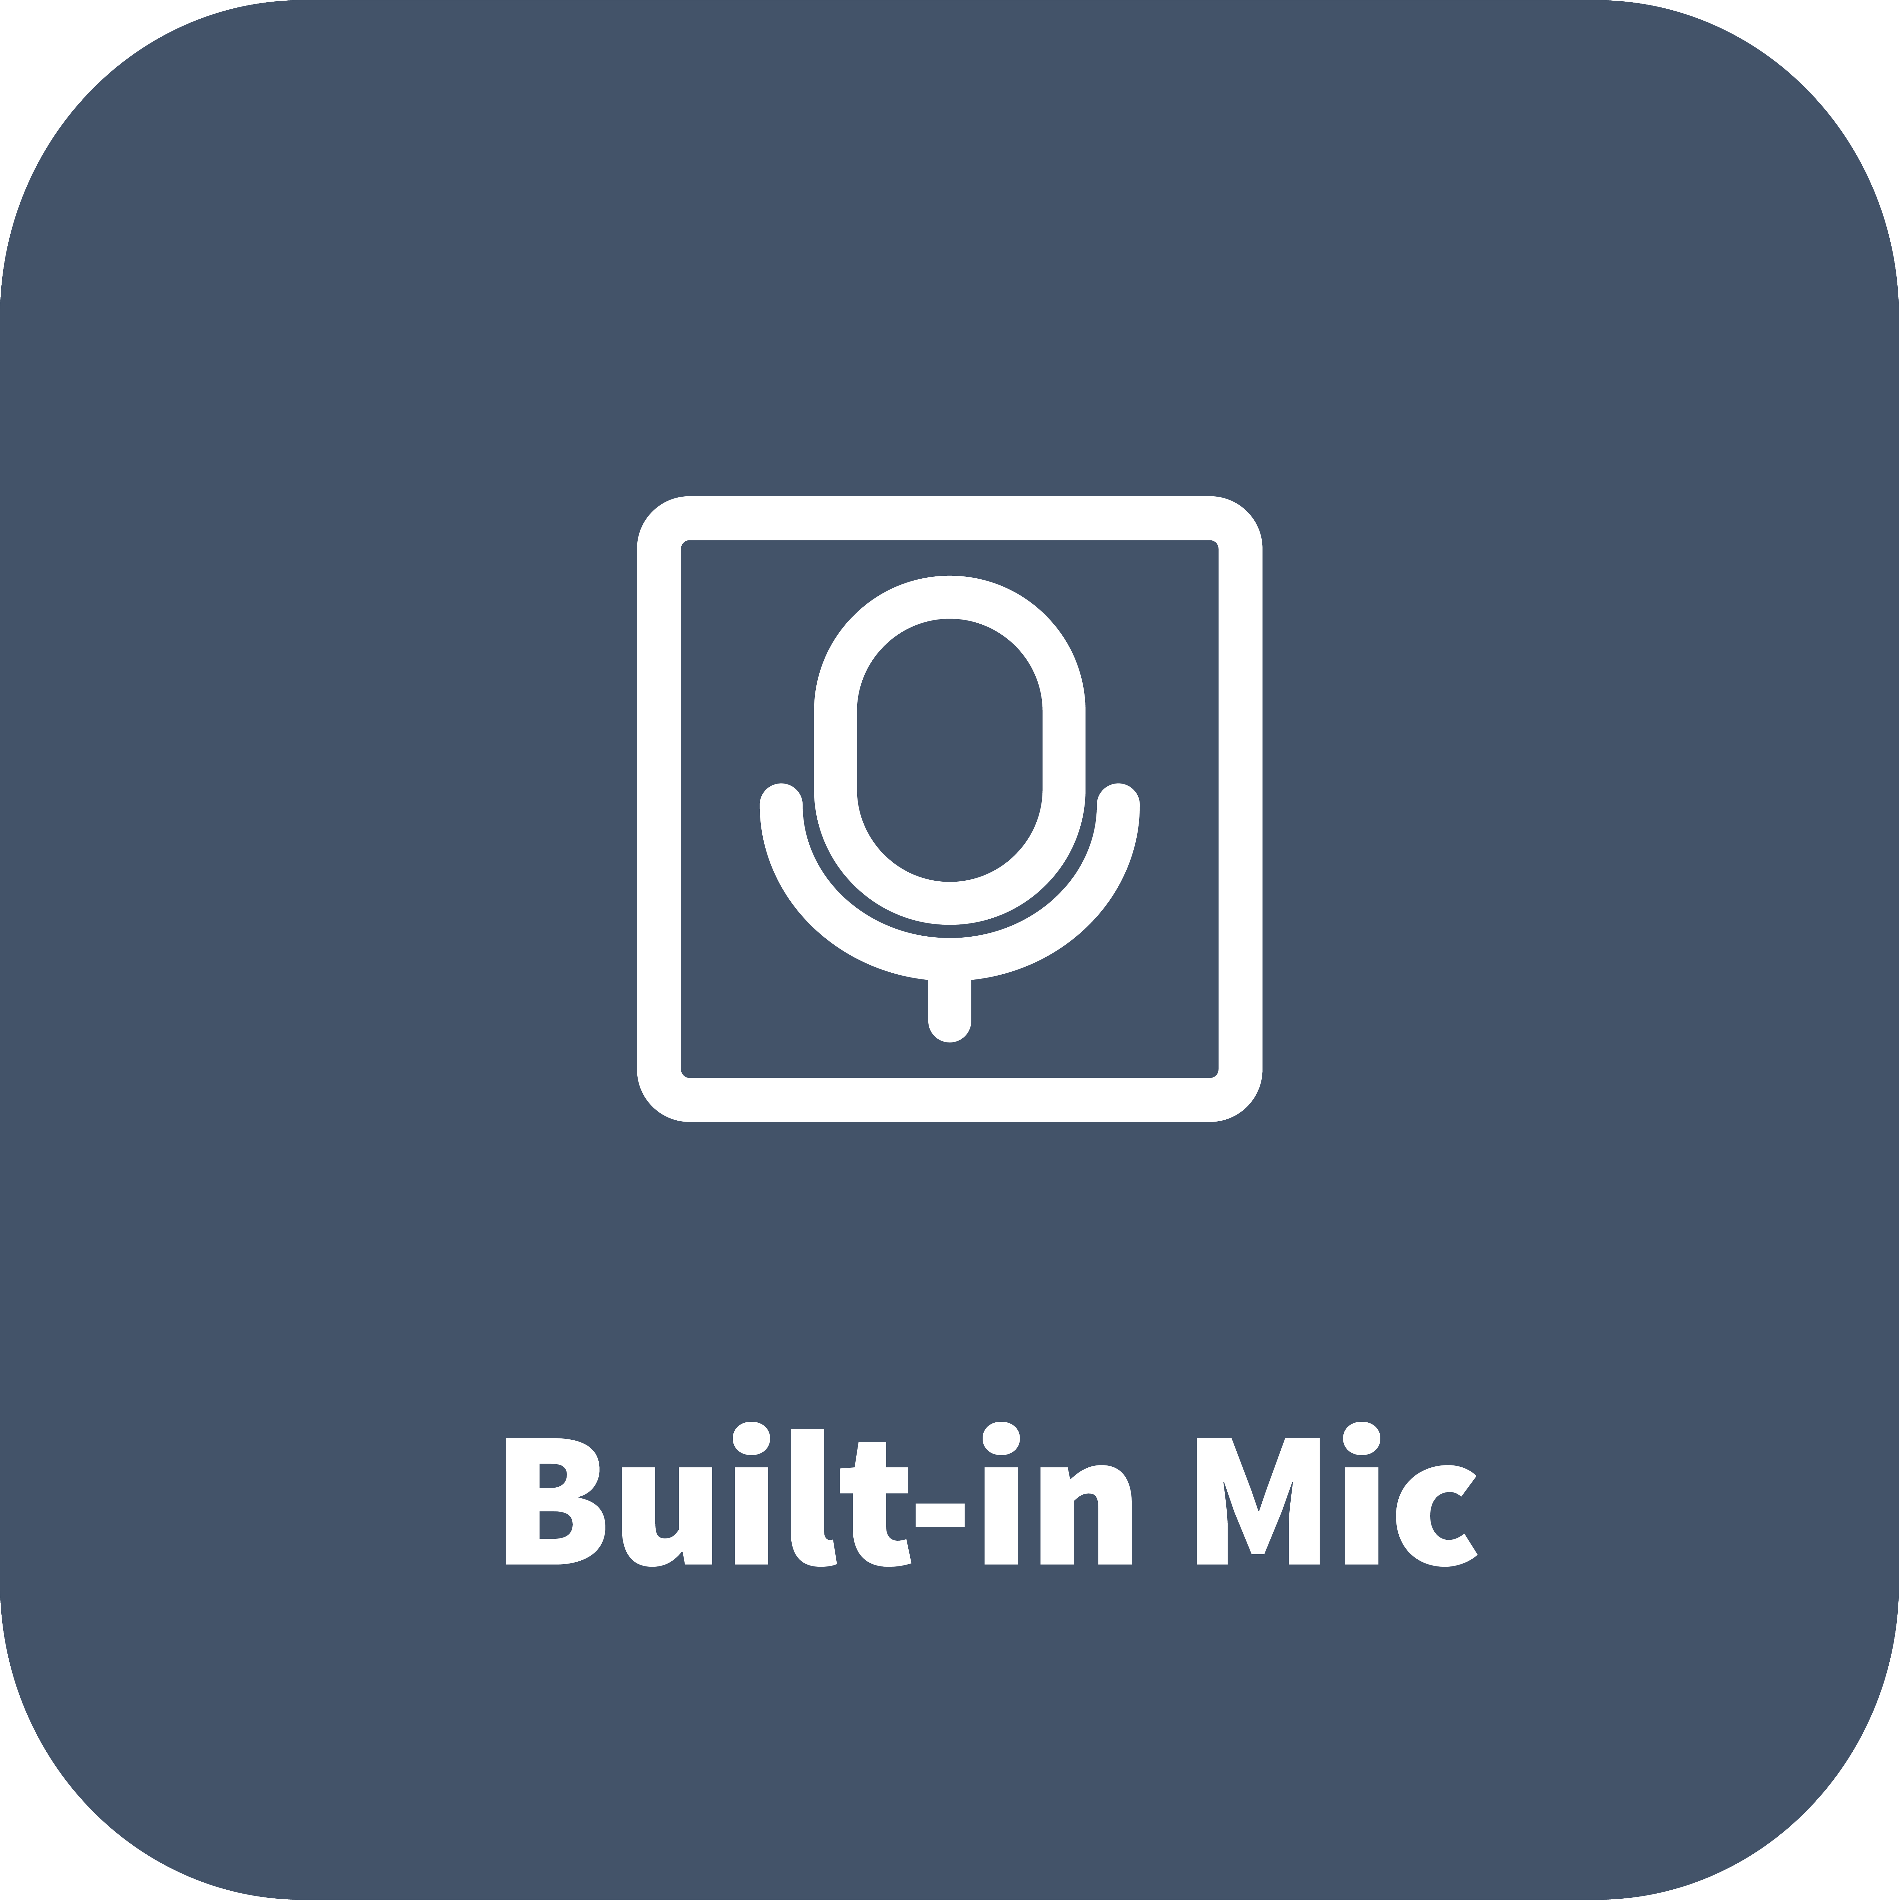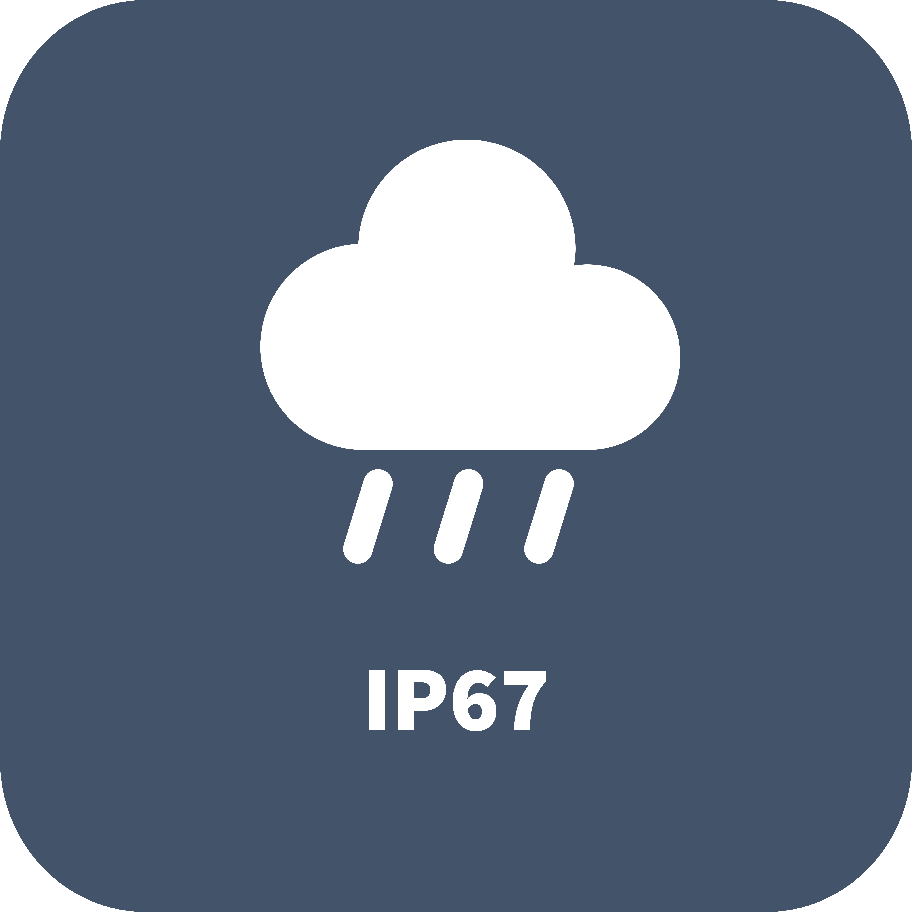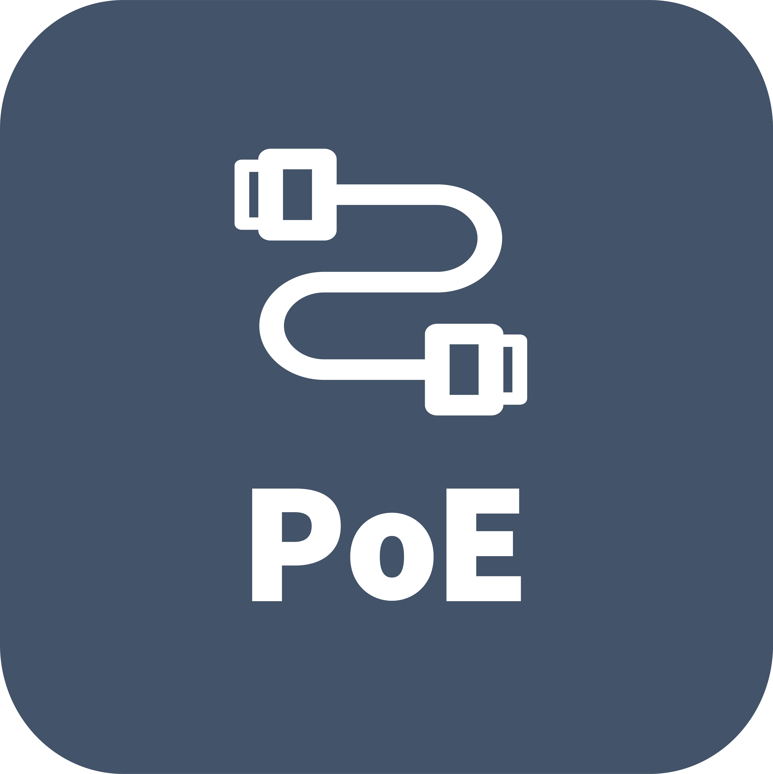

Features
- High quality image with 1080P, 1/3.0" CMOS sensor
- 1080P (1920 × 1080)@30/25 fps; 720P (1280 × 720)@30/25 fps
- Smart dual-light ensures high quality image
- Supports accurate human body detection 2.0
- Ultra 265, H.265, H.264
- 2D/3D DNR (digital noise reduction)
- ROI (region of interest) ensures image quality in areas of interest with low bandwidth
- Smart IR, up to 30 m (98.4 ft.) IR distance
- Warm light, up to 15 m (49.2 ft.) warm light distance
- Built-in mic
- Wide temperature range: -30 ℃ to 60 ℃ (-22 ℉ to 140 ℉)
- Supports PoE power supply
- IP67
Specifications
Model | IPC3612LB-AF28-DL-ECO2
Camera
Max Resolution | 2 MP
Sensor | 1/3.0" CMOS
Min. Illumination | Color: 0.005 Lux (F1.6, AGC ON), 0 Lux with IR on
Day/Night | IR-cut filter with auto switch (ICR)
Shutter | Auto/Manual, 1 to 1/100000 s
Adjustment Angle | Pan: 0° to 360°, Tilt: 0° to 80°, Rotate: 0° to 360°
S/N | > 52 dB
WDR | DWDR
Lens
Focal Length | 2.8 mm
Iris | F1.6
Field of View (H) | 85.1 °
Field of View (V) | 46.6 °
Field of View (D) | 95.9 °
Lens Type | Fixed
Iris Type | Fixed
DORI
DORI Distance (Lens) | 2.8 mm
DORI Distance (Detect) | 51.4 m (168.7 ft.)
DORI Distance (Observe) | 20.6 m (67.5 ft.)
DORI Distance (Recognize) | 10.3 m (33.8 ft.)
DORI Distance (Identify) | 5.1 m (16.9 ft.)
Illuminator
Illumination Distance (IR) | 30 m (98.4 ft.)
Illumination Distance (Warm Light) | 15 m (49.2 ft.)
Wavelength | 850 nm
IR On/Off Control | Auto/Manual
Supplemental Light | Dual light
Video
Video Compression | Ultra 265, H.265, H.264
H.264 Code Profile | Baseline profile, Main profile, High profile
Frame Rate | Main Stream: 1080P (1920 × 1080), max. 30 fps  Sub Stream: 640 × 360, max. 30 fps; 2CIF (704 × 288), max. 30 fps; CIF (352 × 288), max. 30 fps;
Video Bit Rate | 128 Kbps to 6144 Kbps
U-code | Support
OSD | Up to 4 OSDs
Privacy Mask | Up to 4 areas
Snapshot | N/A
ROI | Up to 8 areas
Video Stream | Dual streams
Image
Smart IR | Support
White Balance | Auto, Outdoor, Fine tune, Sodium lamp, Locked, Auto2
Digital Noise Reduction | 2D/3D DNR
Flip | Normal, Flip vertical, Flip horizontal, 180°
Dewarping | N/A
HLC | Support
BLC | Support
Defog | Digital defog
Events
Basic Detection | Motion detection, Audio detection, Human body detection 2.0
General Function | Watermark, IP address filtering, Access policy, ARP protection, RTSP authentication, User authentication, HTTP authentication
Audio
Audio Compression | G.711U, G.711A
Audio Bitrate | 64 Kbps
Two-way Audio | N/A
Suppression | Support
Sampling Rate | 8 kHz
Storage
Edge Storage | N/A
Network
Protocols | IPv4, IGMP, ICMP, ARP, TCP, UDP, DHCP, RTP, RTSP, DNS, DDNS, NTP, UPnP, HTTP, QoS, RTCP, RTMP
Compatible Integration | API, SDK
Client | EZStation, APP
Web Browser | Plug-in required live view: IE 10+, Chrome 45+, Firefox 52+, Edge 79+, Plug-in free live view: Chrome 57+, Firefox 58+, Edge 16+
Security | Password protection, Strong Password, Export operation logs, Basic and Digest Authentication for RTSP, Digest Authentication for HTTP, WSSE and Digest Authentication for ONVIF
User/Host | Up to 32 users. 2 user levels: administrator and common user
Interface
Audio I/O | N/A
Alarm I/O | N/A
Serial Port | N/A
Built-in Mic | Support
Built-in Speaker | N/A
WIFI | N/A
Network | 1 × RJ45 10 M/100 M Base-TX Ethernet
Video Output | N/A
Certification
Protection | IP67 (IEC 60529)
EMC | CE-EMC (EN 55032, EN 61000-3-3, EN IEC 61000-3-2, EN 50130-4)  FCC (FCC 47 CFR part15 B)
Safety | CE-LVD (EN 62368-1)
Environment | CE-RoHS (2011/65/EU ; (EU) 2015/863) ; WEEE (2012/19/EU)
General
Power | PoE (IEEE 802.3af)
Power Consumption | Max. 3.7 W
Power Interface | N/A
Dimensions | Ø117.8 mm × 100.1 mm (Ø4.6" × 3.9") (Ø × H)
Weight | 0.22 kg (0.49 lb)
Material | Graphene + Plastic
Working Environment | -30 ℃ to 60 ℃ (-22 ℉ to 140 ℉), Humidity: ≤ 95% RH (non-condensing)
Storage Environment | -30 ℃ to 60 ℃ (-22 ℉ to 140 ℉), Humidity: ≤ 95% RH (non-condensing)
Surge Protection | 4 KV
Reset Button | N/A
Web Client Language | 1 Language: English
Dimensions
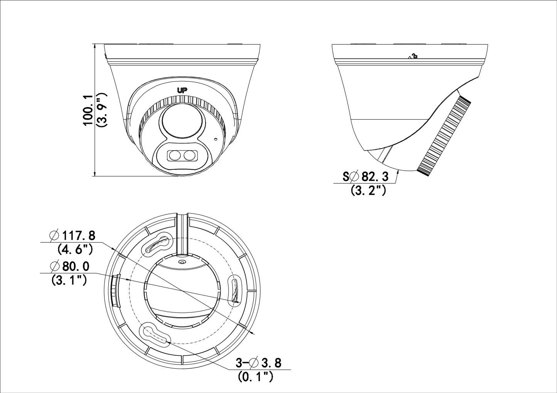
Accessories
TR-JB03-I-IN | TR-A01-IN | TR-SE24-IN
Junction Box for Turret Camera(Support wiring from behind) | NPT 3/4'' Waterproof Cable Gland | Dome Pendent Mounting Pole 200mm
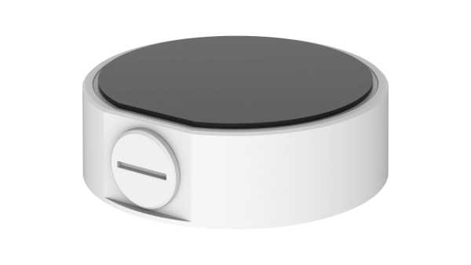 | 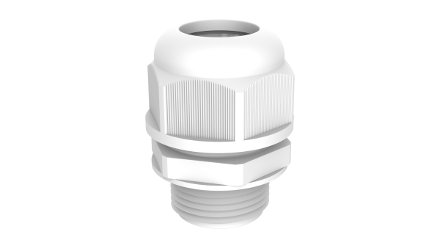 | 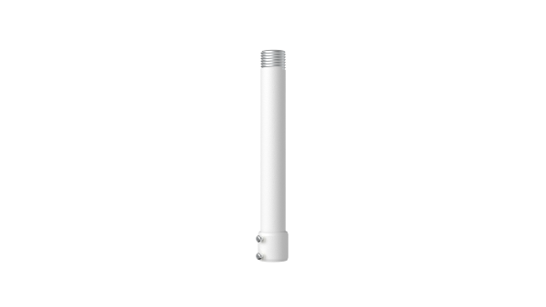
TR-SE24-A-IN | TR-CM24-IN | TR-JB07/WM03-G-IN-V2
Dome Pendent Mounting Pole 500mm | Dome Pendent Mounting Bracket(Indoor) | Wall Mounting Assembling Bracket For 32 Fix-dome&Mini Fix-dome&Plastic Turret Camera
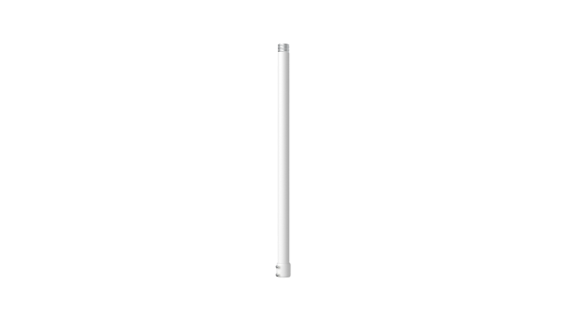 | 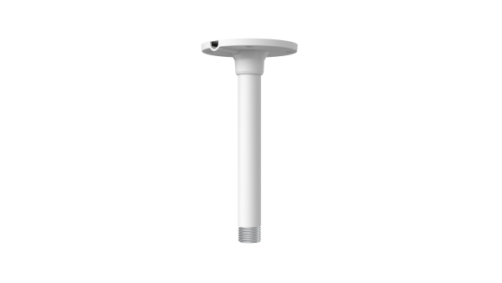 | 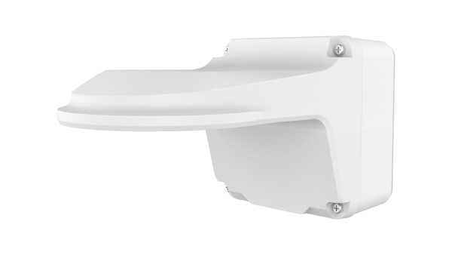
TR-WM03-D-IN-V2 | TR-UC08-C-V2 | TR-UP06-C-IN-V2
Wall Mounting Bracket for 32 Fix-dome&Mini Fix-dome&Plastic Turret Camera | Bullet&Dome Corner Mounting Bracket | Pole Mounting Bracket for Bullet Junction Box Only
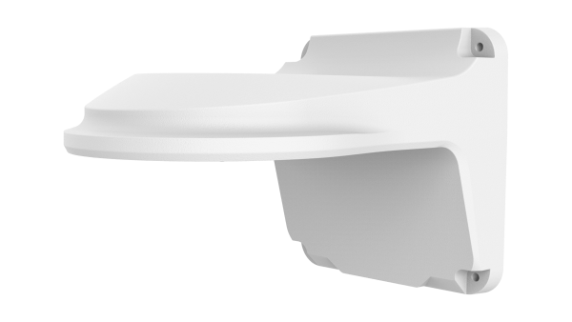 | 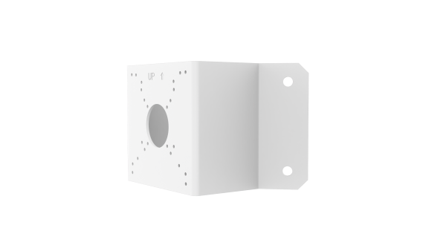 | 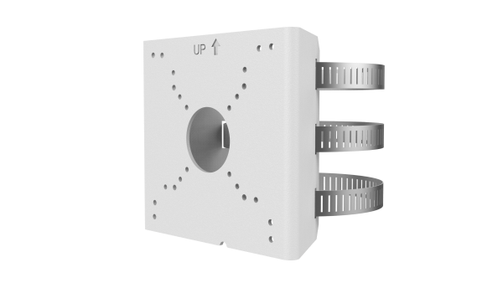
TR-WM07P-B
Dome Wall Mounting Plastic Bracket
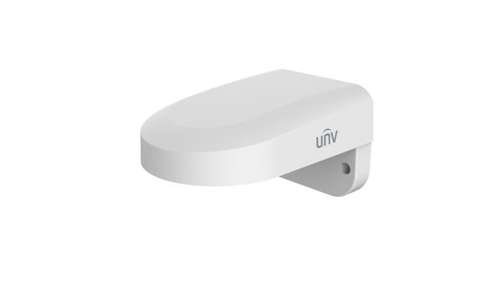

Unlimited New View

Zhejiang Uniview Technologies Co., Ltd. |  | 
 | http://www.uniview.com
 | overseasbusiness@uniview.com; globalsupport@uniview.com
 | No. 369, Xietong Road, Xixing Sub-district, Binjiang District, Hangzhou City, 310051, Zhejiang Province, China
©2026 Zhejiang Uniview Technologies Co., Ltd. All rights reserved.
*Product specifications and availability are subject to change without notice.
Despite our best efforts, technical or typographical errors may exist in this document. Uniview cannot be held responsible for any such errors and reserves the right to change the contents of this document without prior notice.

